GitHub setup

GitHub Desktop setup

Link Eclipse code to GitHub Desktop

Search GitHub in google and Sing in / Sign up



Once u Sign in you will get home page like this.

To create repositories, click on new

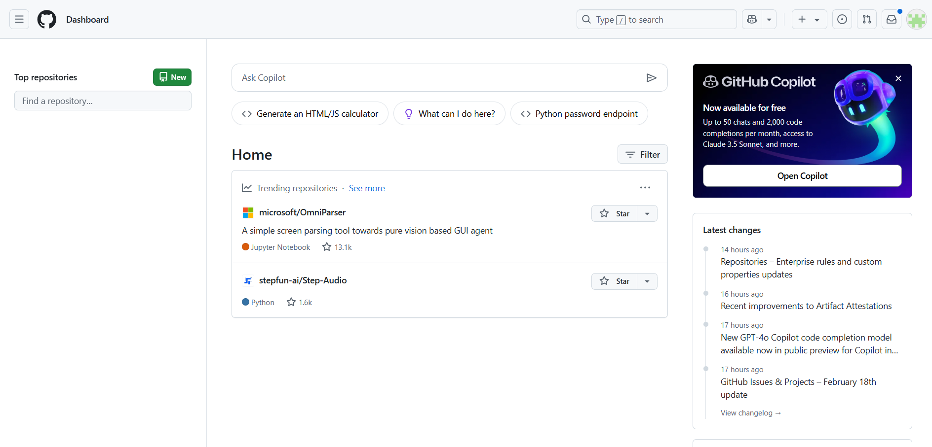

1.Enter repository name

2. Select public or private as per your requirement

3.Then click create repository

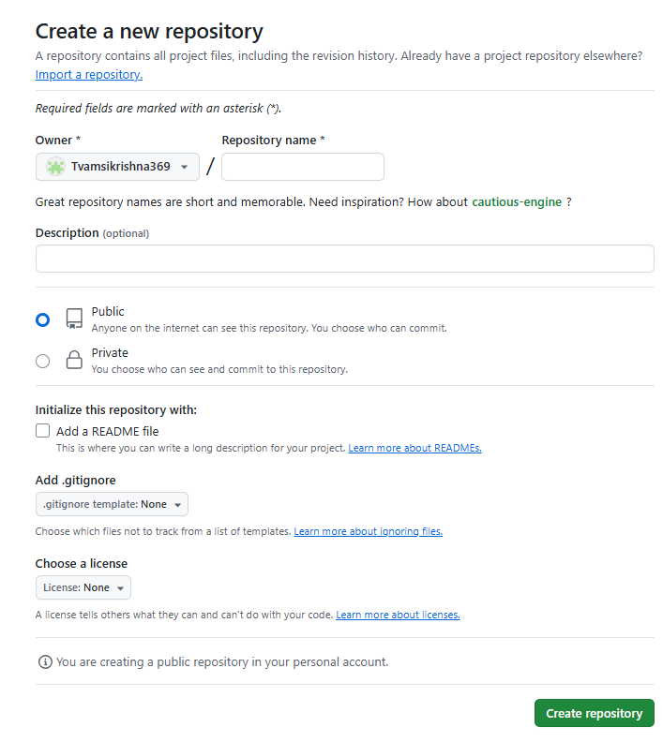

Once you created the repository you will get below screen

1. You can find your repository link.
2. You can find GitHub commands.

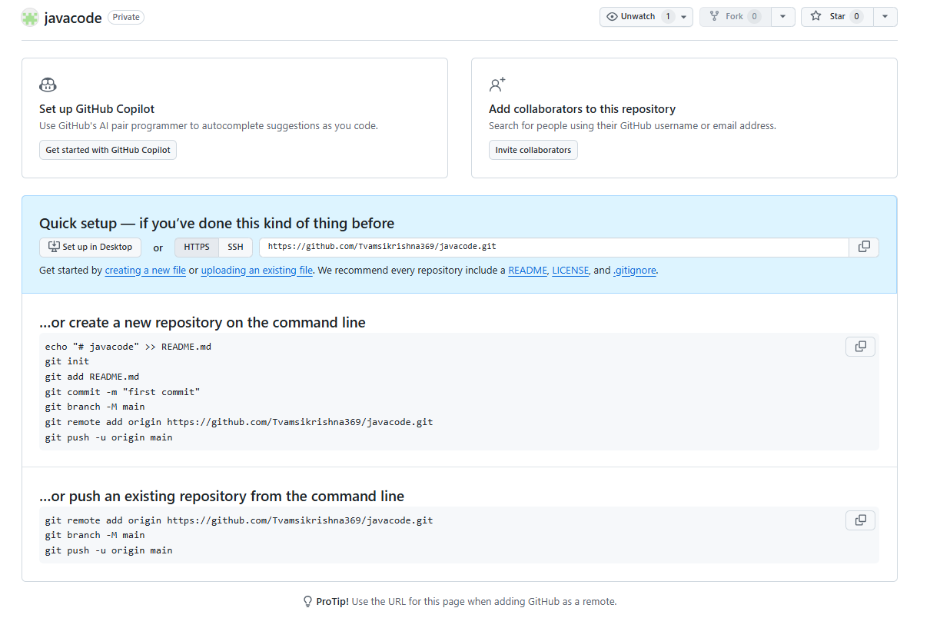

2

1

**GitHub Desktop Setup**

Click the link to download GitHub desktop

<https://desktop.github.com/download/>

once you download you need to configure your GitHub

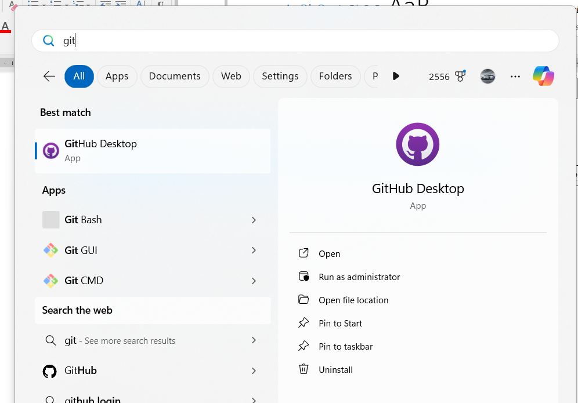

Once you done with configuration you will get below screen

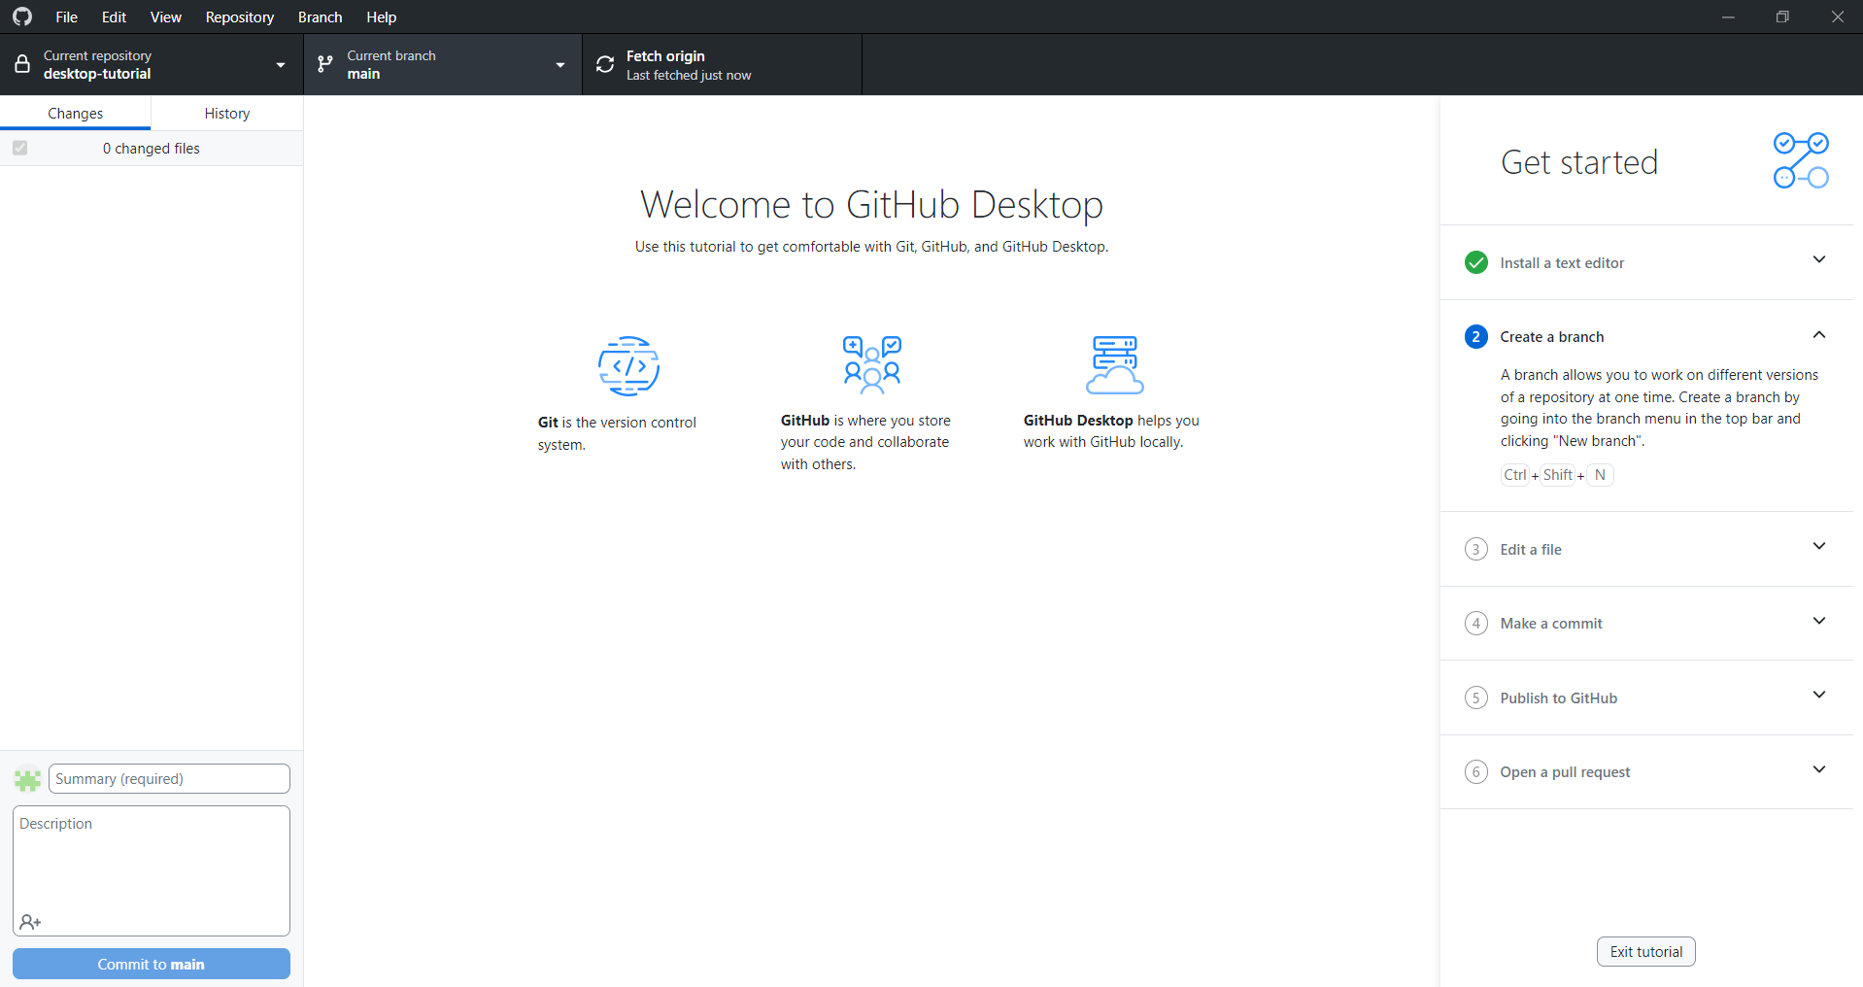

Clone your repository to your GitHub Desktop

Copy your URL from web GitHub

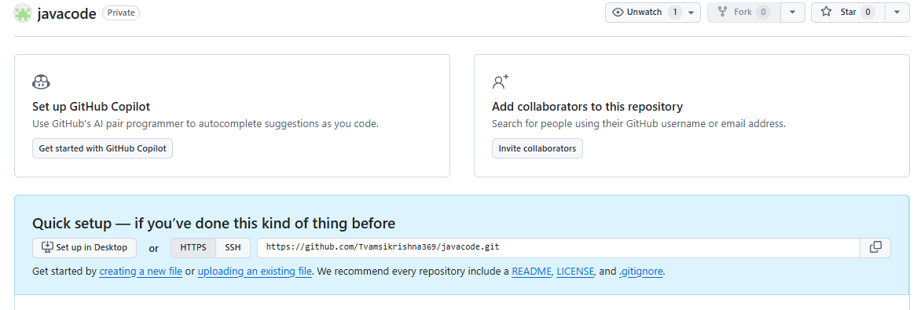

Go to GitHub desktop

1

1. Click add

2

1. Click on Clone repository

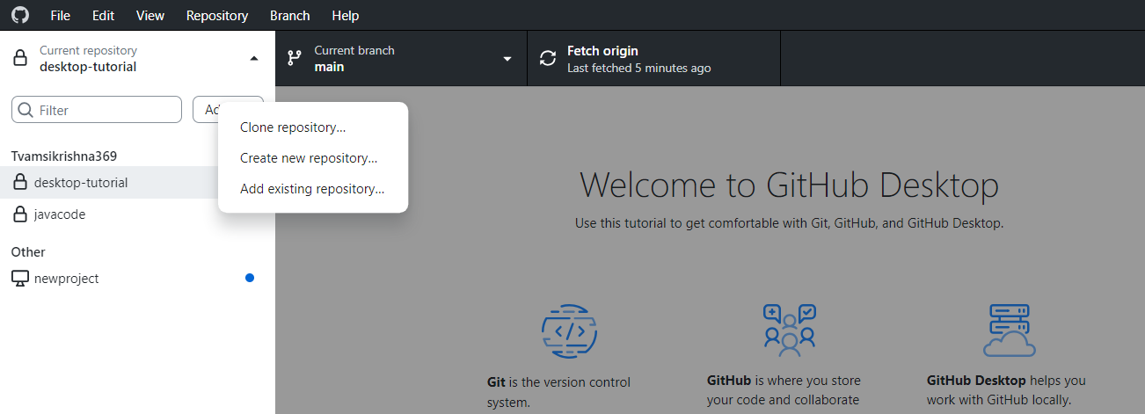

1. Click on URL

1

1. Paste your URL in box
2. Select your preferred local path by clicking choose button
3. Click on clone

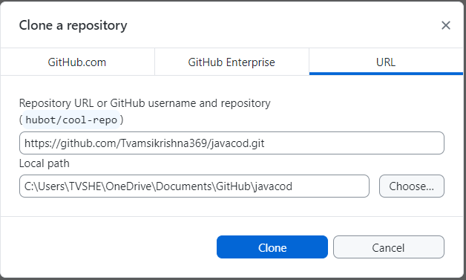

2

3

4

**Link Eclipse code to GitHub Desktop**

1. Click on add
2. Click on Add existing repository

2

1



Click on choose

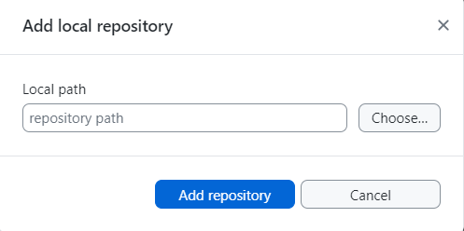

You will get select folder popup and select your saved project file then click on select folder button.

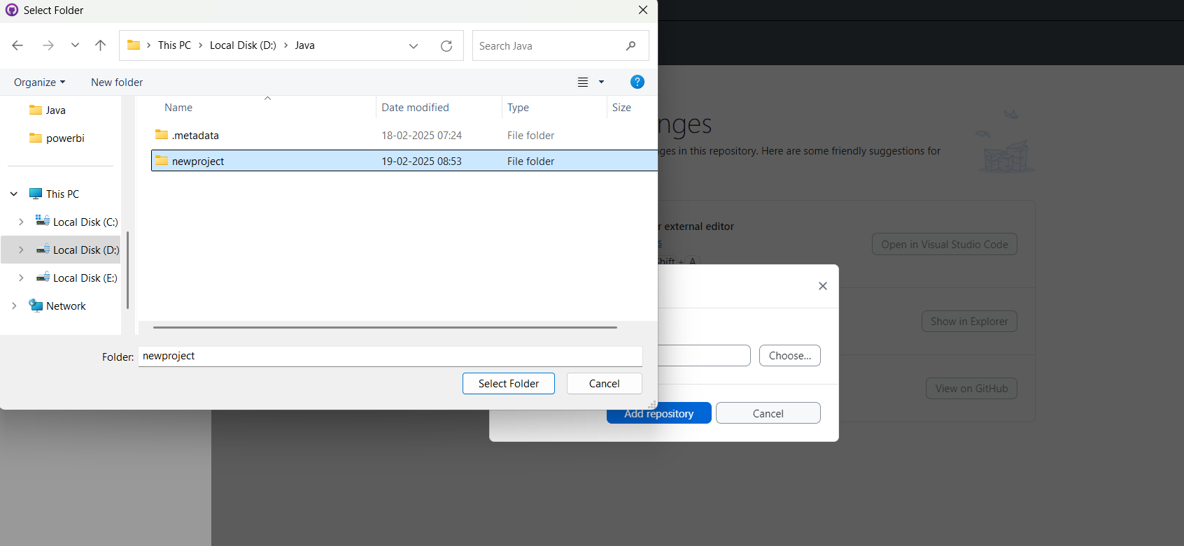

You will get this error then click on create repository

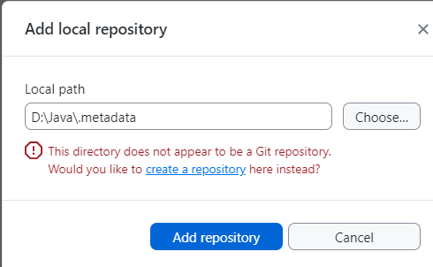

Click on create repository

